Monthly Performance Report – February 2026
Kestrel Ridge Wind Farm (75.6 MW)
David Chen · 09 March 2026 · KR-OPS-RPT-2026-02

1. Summary
Kestrel Ridge generated 20.0 GWh in February 2026, 5.7 % below the P50 budget of 21.2 GWh. Availability fell to 96.2 %, below the contract target of 97.0 %. Mean hub-height wind speed of 9.3 m/s was close to the long-term mean (9.4 m/s). Compared with February 2025 (18.7 GWh), output was up 1.3 GWh.
The replacement gearbox was installed on T-07 between 2 and 5 February with a 750 t crawler crane. T-07 returned to service on 6 February at 14:20 after 23 days offline. Estimated lost production: 1,046 MWh.

A fleet-wide endoscope campaign on all 17 remaining gearboxes started on 16 February.

2. Production and key figures
KPI | February 2026 | Budget / target | YTD 2026 | YTD budget
Net generation (GWh) | 20.0 | 21.2 | 44.7 | 46.4
Time-based availability | 96.2 % | 97.0 % | 95.1 % | 97.0 %
Capacity factor | 39.4 % | 41.7 % | 41.8 % | –
Mean wind speed at hub height (m/s) | 9.3 | 9.4 | – | –
Source: Kestrel Ridge SCADA, revenue meter at 132 kV point of connection. Budget = P50 (2024 post-construction yield assessment).
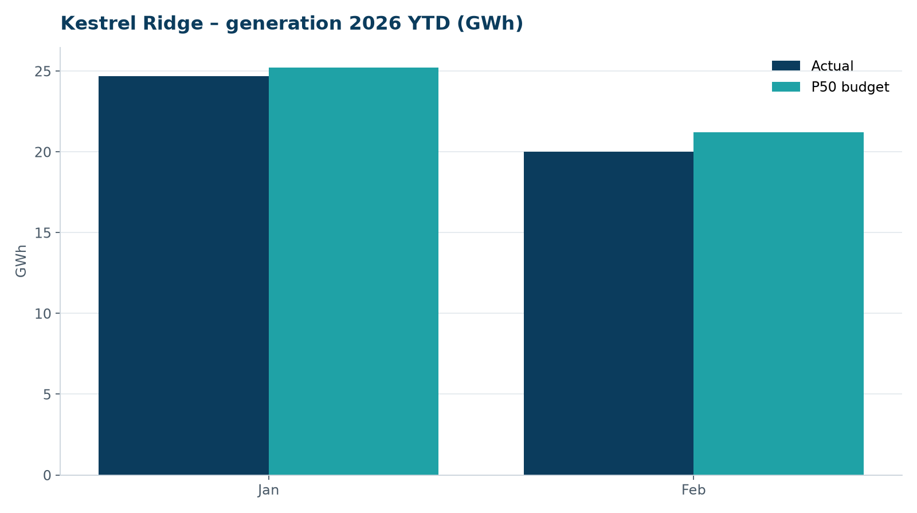
Monthly generation vs. P50 budget, 2026 year to date

3. Availability and downtime
Total turbine downtime attributable to the contractor amounted to 224 turbine-hours for the top events listed below. No grid or force majeure exclusions were claimed this month.
Turbine | Event | Downtime (h)
T-07 | gearbox exchange under warranty – returned to service 6 Feb 14:20 | 134
T-18 | pitch system fault – accumulator pressure low on blade A | 30
T-12 | pitch motor encoder fault on blade B | 25
T-18 | pitch motor encoder fault on blade C | 22
T-07 | nacelle cooling fan motor failure | 13
Top downtime events of the month (SCADA event log, reviewed with Highline Wind Services).

4. Maintenance
- 20 corrective work orders closed, 4 still open at month end.
- Substation monthly inspection completed; no abnormalities on the 33/132 kV transformer.

5. Health, safety and environment
Indicator | Month
Hours worked on site (Highline + Weyland) | 2,997
Lost time injuries | 0
First aid cases | 0
Near misses reported | 2
Safety observations | 9
Environmental incidents | 0

No environmental incidents. Bird carcass searches are paused for the winter (season March–November).

6. Outlook
We will review the downtime events above with Highline in the monthly O&M meeting and track the recurring pitch faults.
Prepared by Sara Lindgren (Performance Analyst); reviewed by Ben Okoye (Site Manager) and David Chen (Asset Operations Manager).

